# Week Two (Week 44)

This week we have to modify our solution, so when the user loads a git repository with the console, we must save the repository into a database. If the user loads the git repository again the database will instead look for changes and only changes those, if it detects any.

The only changes we have to add are infrastructure for repositories, which will allow us to push changes to database when he/she analyses a git repository directory (simply enters the application with a valid git directory). Since the development is test driven, we unit test our changes.

The requirements for this week do not specify to host the database on a server, so we host locally for now.

When the user starts application, he/she will follow specific states:

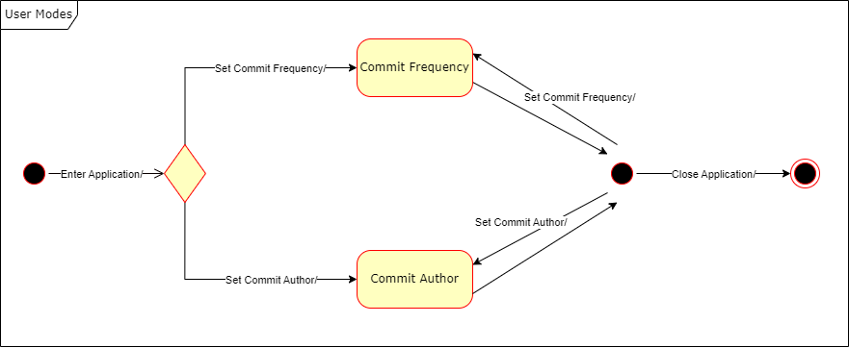

Secrets environment variables…